ARTH 480 * ICONOGRAPHY: Meaning in Art *
Spring 2012
Thursday 3:30-6:15 - Rutledge 127

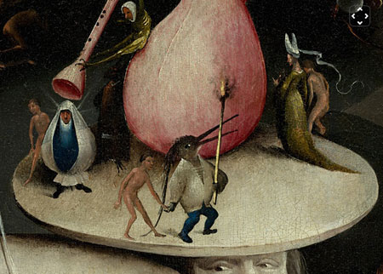

Dr. Laura Rinaldi Dufresne
Office Hours: MW 3:30- 5pm & by appointment
102 McLaurin, x2661, Email dufresnel@winthrop.edu; http://faculty.winthrop.edu/dufresnel/

Required: James Hall Dictionary of Subjects & Symbols in Art, Prentice Hall

Required Articles:
- Woodrow on Panofsky & Iconography: http://w3.gril.univ-tlse2.fr/Proimago/LogiCoursimage/panofsky.htm
- Albert Elsen “Images of Gods” in Writings About Art, ed. Carole Gold Calo Prentice Hall: 1993
- Avram Kampf “The Interpretation of the Second Commandment” in Writings About Art, ed. Carole Gold Calo Prentice Hall: 1993
- Laurie Schneider Adams, “Dreams, Delusions and Art “ in Art and Psychoanalysis, Ch 5, Harper Collins: 1994
- Emil Mâle “Medieval Iconography” Spencer’s Readings in Art History v. 1
- Readings for India lecture see syllabus

Recommended Texts:

James Hall Illustrated Dictionary of Symbols in Eastern & Western Art, Prent. Hall or J C Cooper. An Illustrated Encyclopedia of Traditional Symbols, Thames & Hudson, and access to any standard history of art text that includes Non-Western as well as Western Art (Schneider-Adams, Stokstad, Gardner & Jansen)

Course Content:
This seminar is designed to provide a creative format for the exploration of meaning in art. This will be accomplished through research activities, oral presentations, lectures, film, readings and finally designing a symbolic self portrait. The approach will be broad and thematic, so you may wish to consult a standard art history text to understand the chronological and cultural time periods. GLI: This course participates in the Global Learning Initiative by its very nature."

Expected Student Learning Outcomes:
Upon completion of the course, students are able to identify major symbols used in art by a variety of cultures in Europe and throughout the globe. Students demonstrate these skills in satisfactory written and oral formats, and display competent citation skills on a research paper. They also are able to adapt symbolic imagery to a contemporary context.

Course Requirements: 100 points total
Surrealist Presentation 20
In class Mystery Art Work Activity 10
Article review 25
Symbolic Self-Portrait Presentation & paper 35
Class Discussion & Attendance 10
Grading Scale: 94-100% = A; 90-93 = A-; 87-89 = B+; 84-86 = B; 80-83 = B-; 77-79 = C+; 74-76 = C; 70-73 = C-; 67-69 = D+; 64-66 = D; 60-63 = D-; 59 or less = F
Class Decorum
- Be respectful of the professor and your fellow students in discussions and conduct
- Be on time & be prepared for class; do not text or use cell phones
- Do not miss class (more than 2 absences = point loss)

Do see me with any problems or questions
- If you require special accommodations call Gina Smith 323 2233

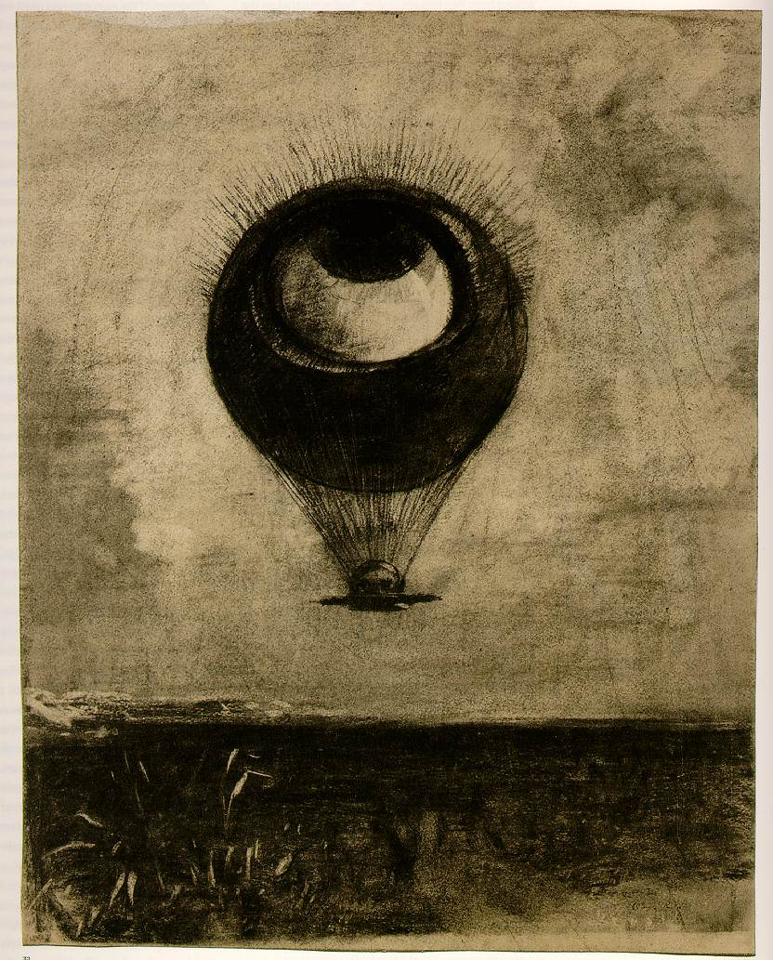

Calendar – check often! (Subject to change) SPRING 2012

R | Jan 12 | Introduction/What is Iconography?  Woodrow on Panofsky & Iconography: http://w3.gril.univ-tlse2.fr/Proimago/LogiCoursimage/panofsky.htm
R | Jan 19 | Classical Gods & Goddesses  5TH discussion of Elsen’s “Images of Gods”
R | Jan 26 | India - Guest Lecture: Dr. Peg DeLamater  READ ONLINE:  1.for Hinduism go to Google and search for Sackler Gallery Puja. Read Puja page and then continue with "next" until they have read to "Worship in Homes". This is about 7 pages. For iconography of three main deities go to "select a section" and click on "How Do I Identify the Different Deities?". Read through.  2. for Buddhism go to www.asia.si.edu/education/ArtofBuddhism and click on Overview of Buddhism. Read pages 5-12
R | Feb 2 | Judeo-Christian Iconography  discussion of Emil Male’s “Christian Iconography”
R | Feb 9 | Symbolists  Discussion of Laurie Schneider Adams “Dreams, Delusions and Art” Ch. 5  -bring group photo to class (family, club, class, etc.)
R | Feb 16 | Surrealist Presentations in Class
R | Feb 23 | Surrealist Presentations in Class
R | March 1 | Miscellany: Marks, Motifs, Animals  Guest Artist: Paula Smith
R | March 8 | Saints  Article Reviews due in Class
R | March 15 | SPRING BREAK
R | March 22 | Mystery Art Work Activity (bring your books, laptops to class)
R | March 29 | The Americas
R | April 5 | Images, Power Propaganda
R | April 12 | Presentations
R | April 19 | Presentations
W | April 25 | Final Exam - 11:30 a.m. Papers/Projects due 5pm  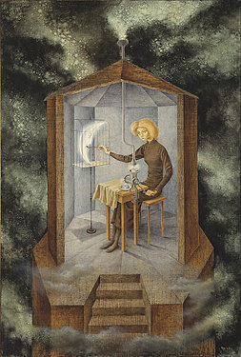

SURREALIST (or Fantasy) PRESENTATION Due Feb. 16 & 23 20 Points

Format:
5-7 minute slide or power point presentation
Typed outline & Bibliography of 3-4 sources needed

- You will choose one work of surrealist art (c.1910 -60) to interpret for the class. (or contemporary fantasy artist)
- Focus on the meaning of this particular work as discovered through research. Give the artists life story only where relevant to the piece.
- You may use artist’s statement, scholarly works, poetry, literature, plays, dream interpretation & especially psychoanalytic theory popular among these artists (Freud, Adler, Rank, and Jung & Others).
Two students may choose the same artist as long as they focus on different works.
Choose a work that has been written about!
Consider: Dali Max Ernst Kahlo Remedios Vara
Klee Arp Joan Miro DortheaTanning
Tanguy Man Ray Leonora Carrington Merit Oppenheim
Magritte Chagall Andre Masson Luis Buñuel
Giacometti DeChirico Valentine Hugo Mark Ryder

See handout on giving presentations attached.

Mystery Art Work Presentation March 22 in class 10 Points

Format:
You will be given a print to analyze, along the facts:
artist or culture, title & date.
- Begin first with Hall or Cooper for clues to decoding your piece.
- Research the piece and give a presentation on its meaning, taking all relevant factors into consideration (culture, religion, location, time period, purpose, etc.)
- See handout on giving presentations attached.

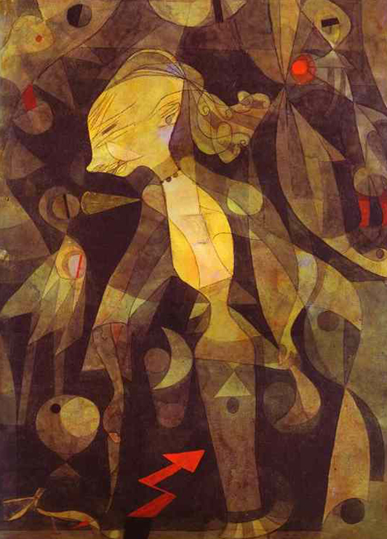

ARTICLE REVIEW Due March 8 25points

Format:
3-4 double-spaced typed pages
FULL citation of your article (title, author, journal, year, publisher, page numbers)
Include images of all pertinent works
Include page number behind all quotes and major points ex. (66)
Staple!!!

Objective:
Choose an article from a scholarly journal primarily devoted to Iconographic study (meaning) in a work, a series, an artist, etc. It can be from any time period or culture. The article should be at least 4 pages long and from a scholarly journal. Have your article approved by me to make sure it fits the requirement.
J-Stor on Dacus Library’s database system is an excellent place to start.
Review your article with regard to the “how to” handout attached.

These are difficult to find, so give yourself plenty of time to locate an article!(see list at end of syllabus)

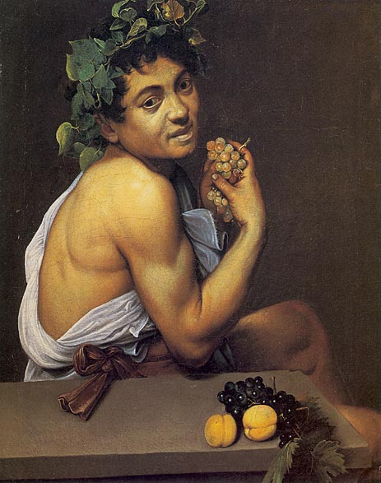

ICONOGRAPHIC RESEARCH PAPER & SYMBOLIC SELF-PORTRAIT
Presentations on April 12, 19th, paper due the 25th
35 points (20 paper, 10 artwork 5 presentation)

Requirements & Format:
7-10 minute presentation
1 symbolic self-portrait – any medium
8-10 double spaced, typed research & process paper
Copies of all images discussed
6 sources for bibliography (one must be an old fashioned book)

Objective:
Research an iconographic system which fascinates you; the labors of Heracles, Viking runes, Egyptian Hieroglyphs, the martyrdom of St. Appolonia, Botticelli’s Primavera, Chartres Cathedral, pure land Buddhism, Tlingit Masks, Mayan jaguars……..in Caravaggio’s case above, the bacchanal, etc.

Create:
Create a symbolic self portrait in any medium.
The self portrait must be decipherable according to some symbolic system discussed in class (ex. Classical, Buddhist, prehistoric, Freudian, etc.) or researched by you – just run it by me first!

Paper/Presentation
Immerse yourself in a symbolic language. If Hindu art is your source of inspiration, read everything you can about it – religious books, myths, history, etc. You can choose the symbolic system of a, a culture, a faith, a sect or even an individual. Include in your paper/presentation an analysis of the symbols and their meaning, and why you choose them. Discuss all influences in your piece of which you are consciously aware.

GUIDE LINE FOR FORMAL PRESENTATIONS

TEXT:
- 10 MINUTES IN LENGTH (THIS EQUALS 4-5 PAGES OF DOUBLE SPACED TYPED TEXT)
- PRACTICE READING PAPER ALOUD SEVERAL TIMES – ARE THEIR WORDS YOU HAVE DIFFICULATY PRONOUNCING? WRITE THEM PHONETICALLY IN YOUR TEXT IF NECESSARY. Don’t say in presentation “I don’t know how to pronounce this word”.
- TRY TO READ SLOWLY & CLEARLY
- MAKE EYE CONTACT WITH THE AUDIENCE AS OFTEN AS POSSIBLE
- IF YUOU ARE NERVOUS, JUST READ PAPER. DON’T TRY TO “AD LIB.”
IMAGES:
- NOTE ON YOUR PAPER WHEN TO CHANGE IMAGES IN YOUR TEXT
- SUGGESTIONS FOR POWER POINTS:
  - FIRST “SLIDE” SHOULD HAVE YOUR PAPER TITLE & YOUR NAME
  - GOOD CLEAR IMAGERY AGAINST SIMPLE BACK GROUND (BLACK)
  - LIMITED TEXT-DO NOT INCLUDE YOUR ENTIRE PAPER!!!
  - IDENTIFICATION OF ALL IMAGES USED
  - LOOK AT YOUR IMAGES DURING PRESENTATION – YOU MIGHT HAVE THE WRONG ONE UP! POINT OUT IMPORTANT DETAIL WHEN APPROPRIATE.
  - CAN HAVE BIBLIOGRAPHY AT THE END
- ALWAYS CHECKOUT THE ROOM AND ITS TECHNICAL EQUIPMENT AHEAD OF TIME IF AT ALL POSSIBLE TO AVOID PROBLEMS.
- AT THE END OF A PRESENTATION SAY SOMETHING LIKE:
“THANK YOU, ARE THERE ANY QUESTIONS?”
UPDATED: HOW TO REVIEW AN ARTICLE/BOOK
Dr. Laura Rinaldi Dufresne (2009-10)

State Author, Title of article, Journal / Book Title, Date of Publication.

- Demonstrate you understand the Author’s Thesis

- Thesis Statement. Why was this article/book written? Purpose?
State Thesis in One or Two sentences only! Be concise – then elaborate: What are the supporting points/ evidence used to support the thesis?
- How is the article/book structured? Thematic or Chronological subheadings?
- Identify (if any) rhetorical strategies the author uses to persuade the reader – concern for fairness / justice? Appeal to logic, reasoning? A plea to emotions?
- Identify any obvious methodological approach use by the author (hint: what is their background, education, training, career)
Aesthetic/Formal? Cultural/Sociological? Psychological? Historical/biographical? Political (ex. Feminist? Marxist) Iconographic? Groundbreaking? Theoretical? Other?
- Is there an obvious tone to the article? Persuasive? Emotional? Scholarly? Logical? Educational? Detached? Personal? Humorous?
- Who is the intended audience? Students? Colleagues? Artists? Public?

II Was the article successful?

- Once you establish that you understand the author’s thesis (Part I), you can address how successful you believe the author was in proving or persuading you (the reader) regarding his or her thesis.
- Do you agree or disagree in whole or in part with the author’s thesis? Ground your response in sound reasoning, evidence or experience.
- Were there any particularly exciting and memorable observations that you found important or persuasive?

- Keep in Mind

- The articles are often difficult to read. This is not necessarily a fault.
- You are not grading the article on whether it is well written or not – rather, you should focus on the merit of the ideas presented.
- Paraphrase as often as you can. Avoid long quotes.
- Cite all sources properly, even when paraphrasing.
- If presenting review in class – do not read from a highlighted Xerox of the article! Have note cards or written statement.

A selection of iconography scholars:

Famous, but older…Erwin Panofsky, Fritz Saxl, Wendy Steiner, Aby Warburg, Martin Kemp, Rudolf Wittkower, Millard Meiss, Gertrude Schiller, Ananda K. Coomaraswamy (Buddhism) Donald A. Proulx (pre-Columbian)

Some articles I stumbled across to consider:

Debra Higgs Strickland: | “Antichrist, and the Jews in Medieval Art and Protestant Propaganda”
Elina Gertsman: | “Image as Word: Visual Openings, Verbal Imaginings”
Nina Rowe: | “Pocket Crucifixions: Jesus, Jews and Ownership in Fourteenth-Century Ivories”
Paula Mae Carns: | “Remembering Floire et Blancheflor: Gothic Secular Ivories and the Arts of Memory”
Richard A. Leson: | “Heraldry and Identity in the Psalter-Hours of Jeanne of Flanders(Manchester, John Rylands Library,
The Bayeux Tapestry: New Interpretations, ed. Martin K. Foys, Karen Eileen Overby, and Dan Terkla
By Herbert R. Broderick
Maria Vassilaki, The Painter Angelos and Icon-Painting in Venetian Crete
By Maria Evangelatou
Andrew Ladis, Giotto’s O: Narrative, Figuration, and Pictorial Ingenuity in the Arena Chapel. Anne Derbes and Mark Sandona, The Usurer’s Heart: Giotto, Enrico Scrovegni, and the Arena Chapel in Padua. Laura Jacobus, Giotto and the Arena Chapel: Art, Architecture and Experience
By Holly Flora
Beth Williamson, The Madonna of Humility: Development, Dissemination & Reception, c. 1340-1400
By M. A. Michael
ALSO Norma Broude & Mary Garrard Feminism and Art History & The Expanding Discourse 2 books of essays.
Indian Sculpture & Iconography (9781890206376): Ganapati V. Sthapti: Books.
Haig David-West African Iconography in Contemporary Afro-Cuban Visual Art

Other resources:
Index of Christian Art:
http://ica.princeton.edu/studies.php

Daoist Iconography Project: http://manoa.hawaii.edu/daoist-iconography/

For Greek Orthodox Ptg? http://www.iconographyalmanac.com/

